Understanding Placemaking Practices in Sacred Landscapes for the Conservation of Heritage:
Insights from Jeevant Braj, India
Rohan Chaturvedi
RV College of Architecture, India
Email: rc.arch02@gmail.com
Received | Accepted | Published
01.12.2025 | 22.01.2026 | 30.01.2026
https://doi.org/10.61275/ISVSej-2026-13-01-02

Abstract
Sacred landscapes present a layered heritage where tangible structures, ritual practices, collective memory, and performative traditions interweave to shape spatial identity. Contemporary development pressures, commodification, and fragmented conservation efforts often reduce such landscapes to stand-alone relics or contested spaces, overlooking their lived, performative, and narrative dimensions deeply rooted in devotional texts. In this context, this paper examines how conservation of such heritage could be implemented without erasing socio-cultural vitality. In order to facilitate conservation of ritual geographies to foster cultural continuity and social inclusion, it examines the placemaking practices of Braj: a sacred region in India.
The research employs case study as a method focusing on the Braj region. Data gathering involve four techniques: (1) archival research examining historical maps and Puranic and Bhakti texts (2) spatial documentation, mapping of key sites, parikramā routes, and settlement patterns, (3) ethnographic observation of daily rituals, major festivals, Rāslīlā performances, and food practices (4) oral histories from interviews with diverse community members. Comparative analysis of studies on other pilgrimage sites and heritage interventions contextualizes the findings.
The paper concludes that placemaking in Braj follows a continuum where geography precedes and shapes sacred identity informed by rich textual traditions. The traditions are activated by rituals and performances, with temples contributing to the articulations. The paper argues that heritage can be enriched through architectural interventions acting as catalysts for cultural continuity, addressing contestation, and supporting sustainable community engagement. It thus proposes a model for design practice foregrounding participation and spatial storytelling informed by scriptural narratives, and adaptive reuse. It offers pathways for integrating contemporary functions into heritage contexts while sustaining their cultural resonance and contributing to sacred rural culture and life.

Keywords: Sacred Landscapes, Living Heritage, Placemaking, Ritual Geography, Collective Memory, Braj, India

Introduction
Vernacular settlements are often repositories of living traditions where placemaking emerges as a continuous social process. The sacred region of Braj in India exemplifies such a landscape, where a layered heritage of tangible structures, ritual practices, collective memory, and performative traditions interweave to shape a unique spatial identity. According to Hindu traditions, whole of India can be regarded as a vast sacred space organized into a network of pilgrimage centers which are the tīrthas (Eck 2012 ; Singh & Rana 2023).
Situated primarily in the trans-Yamuna basin of North India, Braj encompasses key towns like Mathura and Vrindavan alongside numerous villages and natural sites, forming a vibrant pilgrimage circuit attracting millions annually (Chaturvedi n.d.; Singh & Rana 2022). As argued by Sinha (2014), this landscape is simultaneously imagined, enacted, and requires reclamation. The imagined landscape is heavily shaped by centuries of devotional literature taking from Bhakti texts such as the Garga Samhita, Bhagavata Purana, Chaitanya Bhagavata and Bhakti-rasamrta-sindhu etc. They describe Braj not merely as geography but as the earthly stage for Krishna’s divine play (līlā), imbuing every forest, riverbank, and hillock with sacred narratives. The landscape is enacted via ritual circumambulation (parikramā) and performances, inscribing places onto the body, but require reclamation due to environmental degradation (Sinha 2014).
These landscapes, however, experience transformations due to contemporary development pressures including rapid urbanisation, increased tourism, commodification of religious experience (Taneja, 2023), and conservation efforts that sometimes isolate monuments or create contested spaces (Gahalot & Gupta, 2024). Such changes risk overlooking the lived, performative, and narrative dimensions integral to the meanings of Braj, as evidenced in reports on ecological stress, challenges to traditional livelihoods, and unregulated construction impacting ritual spaces (Sinha, 2014; Shinde, 2010; Millennium Post, 2024; The Statesman, 2017). This paper addresses the issue of how architecture and design can operate within these deeply resonant, living contexts without erasing their socio-cultural vitality. Accordingly, the study foregrounds placemaking as the lens through which the interplay of geographies, narratives, and rituals are analyzed to understand how sacred landscapes in Braj take form.
The aim of this study is to examine the vernacular placemaking practices of Braj to understand how its sacred landscapes are produced and sustained through the interplay of geography as interpreted through devotional texts, ritual, performances, and collective memories, while acknowledging contemporary pressures of contestation and commodification.

The objectives are:
- To establish the relationship between geographical features, as tangible and intangible aspects, informed by Bhakti narratives, ritual practices (especially parikramā), performance traditions, and built forms in the Braj region.
- To identify the placemaking practices within the settlements of Braj focusing on the specific typologies of sacred spaces and performances, including the 84 Kos Parikramā tradition.
- To derive insights from the placemaking practices of Braj as relevant to contemporary heritage conservation, community engagement, and the regeneration of contested sacred spaces
- To contribute to the understanding of sacred rural culture and life in India.

Theoretical Framework
This study draws upon interconnected theories of 'place', 'placemaking', 'vernacular' landscapes, and 'sacred landscapes'. Following phenomenologists like Yi-Fu Tuan (1977), 'place' is understood as a center of meaning constructed from lived experiences. As Sinha (2014) applies this to Braj, the landscape is experienced through visual and haptic engagement during ritual enactments, informed by an imagined geography derived from the devotional texts. As Relph (1976) and Norberg-Schulz (1980) articulate, 'placemaking' is the ongoing, collective process of imbuing spaces with meaning. According to Rapoport (1969), 'vernacular' directs attention to landscapes shaped by cultural traditions and socio-behavioural factors.
Crucially, this paper utilizes Mircea Eliade's (1959) distinction between sacred and profane space. Sacred space, according to Eliade (1959), is established through hierophanies, manifestations of the sacred in ordinary reality—creating sacred centers (axis mundi) that orient the world, connect cosmic levels, and often link to natural features described in the sacred narratives. Rituals reactivate sacred time: the mythical time of origins (illud tempus), allowing participants to become contemporary with foundational events (Eliade, 1959). Singh builds on this, conceptualizing 'sacredscapes' defined by symbols, traditions, and festivals (Singh & Rana, 2023), within a larger national 'faithscape' (Singh & Rana, 2023). According to Diana Eck (2012), central to the sacredscape of Braj is the principle that physical tangibles serve as mediums for metaphysical connections, where geography itself becomes a theophany, interpreted through the lens of scripture.
Haberman's (1994) ethnography highlights the embodied encounter in Braj pilgrimage (yātrā), where the landscape is read as a sacred text reflecting Puranic and Bhakti narratives, and experienced as Krishna's living presence. Pilgrimage becomes a performative act, aligning with anthropological understandings of pilgrimage as a liminal process involving separation, transition, and incorporation (Turner, adapted by Singh & Rana, 2023). Indeed, performance traditions, like the Rāslīlā, are central forms of placemaking. As Mason (2009) demonstrates, Rāslīlā is embodied theology where actors become divine manifestations (svarūps), enacting the divine līlā described in the texts like Garga Samhita or Chaitanya Mangala within ritually charged spaces (ras mandals), collapsing the distance between performer, audience, and deity. The experience is multisensory, shaped by foodscapes–the system of offering, consecration, and distribution of sacred food (prasāda)–which forge tangible connections between devotees, deities, and communities (Singh, 2023). The entire cultural heritage reflects a synergy between Nature, agriculture (especially cow veneration), and scripture (Chauhan,2024), where texts inform the perception and veneration of the landscape. However, as Gahalot & Gupta (2024) note, sacred landscapes can also become contested spaces, requiring regeneration efforts.

Review of Literature
The study of Hindu pilgrimage places from a cultural geography perspective has been significantly advanced by Bhardwaj (1973). Foundational theoretical contributions have come from Mircea Eliade (1959) on sacred space and time. Phenomenological approaches (Tuan, 1977; Relph, 1976; Norberg-Schulz, 1980) and vernacular studies (Rapoport, 1969) provide frameworks for understanding experience and culturally embedded practices. Sinha (2014) applies phenomenological and landscape perspectives directly to Indian contexts, including Braj, focusing on imagined, enacted, and reclaimed landscapes.
Within Indian studies, Singh extensive oeuvre provides a comprehensive framework for understanding sacred geography, developing concepts like 'sacredscape' and 'faithscape' and analyzing sites like Varanasi (Singh, 1997; Singh & Rana, 2011; Singh & Rana, 2023b) and Khajuraho (Singh, 2009). Diana Eck's (2012) India: A Sacred Geography offers a pan-Indian perspective on the tīrtha network interwoven with narrative.
Historical research of Entwistle (2025) remains foundational specifically concerning Braj. Haberman (1994) provides the most definitive ethnographical account of the Braj Yātrā's embodied experience, reading the landscape through textual lenses. In contrast, Singh and Dubey (1988) focuses on Mathura's mandala structure. Added to this, Gupta (2019) details the history and archaeology of the 84 Kos Parikramā. The textual traditions themselves for example, Garga Samhita, Chaitanya Bhagavata, Brihad Bhagavatamrita, Bhajana-Rahasya, Bhakti-rasamrta-sindhu, Prem Sagar, Chaitanya Mangala) provide primary sources describing Vrindavan and Braj as sacred forests, sites of divine līlā, filled with natural beauty, and imbued with devotional emotion. Elaborating these Mason (2009) presents performance traditions, particularly the Rāslīlā, as being central, explored as embodied theology and placemaking. Chauhan (2024) examines the synergetic influence of Nature, agriculture, and scripture
Contemporary transformations are increasingly studied. For example, Taneja (2023) analyzes commodification. In contrast, Shinde (2010) discusses performance transformations and potential 'cacophony'. Adding to this, Gahalot and Gupta (2024) explore sacred landscapes as contested spaces. Moreover, Gulati et al. (2024) examining conservation studies provide data on tangible heritage, pressures, and revitalization strategies. Peleggi's (2021) "devotional conservation" offers a historical lens, while Ray (2019) links ecology and devotion. Pandey (n.d.) inform historical narratives through scribal traditions.
While literature exists on these components, a gap remains in synthesizing textual portrayals (Bhakti literature), phenomenology (Sinha, 2014), performance (Mason, 2009; Shinde 2010), historical parikramā (Gupta 2019), commodification (Taneja 2023), contestation (Gahalot & Gupta, 2024), conservation (Gulati et al., 2024), and ecology (Chauhan, 2024) to analyze placemaking in Braj. In fact, existing scholarship often prioritizes either descriptive documentation or thematic emphasis, with fewer studies offering critical assessments of how narrative, ritual, and spatial practices co-produce place. Moreover, while several authors detail aspects of the geography or performance traditions of Braj, they do not explicitly frame these as placemaking processes embedded within the lived landscapes.
This study addresses this gap by integrating textual, ethnographic, and spatial insights.

Research Methods
This paper employs a case study as its primary research method, focusing on the Braj region. A qualitative, interpretive methodology integrates several data-gathering techniques.

- Archival Research: Historical maps were sourced from relevant archives, alongside colonial-era gazetteers, Puranic texts, key Bhakti literature (e.g., Garga Samhita, Chaitanya Bhagavata excerpts), historical studies on the Braj Yātrā (Gupta 2019), and analysis of scribal accounts where available (Pandey n.d.) to understand historical layers, mythological associations, textual descriptions of the landscape, and narrative construction.

Table 1: Bhakti Literature mentions of Vraja
Source: Author

Text | Focus on Vrindavan/Vraja | Relevance for Placemaking (Interpretation)
Garga Samhita | Describes Vrindavana as a sacred forest and the location for the rasa dance, holding significant spiritual importance. Vraja is the kingdom/region where the cowherds reside and where a divine figure collaborated to create a mound of edible items. | Establishes the core identity of the place as a sacred, performative stage, linking geography to divine action (līlā).
Chaitanya Bhagavata | Portrays Vrindavana as a sacred place associated with Lord Krishna's pastimes and the presence of Vrindadevi. Vraja is the region/village where Krishna grew up, characterized as his realm of authority. | Reinforces the landscape as a realm of divine love and authority, shaping the perception of the settlements and geography.
Brihad Bhagavatamrita | Describes Vrindavana as an attractive and beautiful location containing numerous ponds where water remains fragrant. Vraja is where the love of the gopis is considered topmost. | Provides the sensorial and emotional descriptions that inform the ritual veneration (e.g., in Kunds) and collective memory.
Bhajana-Rahasya | Focuses on Vrindavan as the location of the solitary nikunjas (groves) where Shri Radha met Shri Krishna. Vraja is the land where Krishna's interactions with the gopis take place. | Directly links specific, intimate spaces (groves) to divine encounters, justifying their treatment as intangible performance spaces.
Bhakti-rasamrta-sindhu | Describes Vrindavan as the glorious land where Krishna protects cows and engages in divine pastimes. Vraja is the location whose inhabitants exhibit spontaneous devotion (kevala-rati). | Establishes the link between the landscape, agriculture (cow protection), and the pure devotion that defines the socio-cultural vitality
Prem Sagar (English) | Depicts Vrindavana as a land that appears beautiful, likened to a loving woman adorned with ornaments. Vraja is the home of Shri Krishna and the cowherd people. | Provides visual and emotional narratives that underpin the imagined landscape and collective memory.
Chaitanya Mangala | Portrays Vrindavana Forest as charming, where Lord Krishna is surrounded by gopis, and the land is made of cintamani jewels. | Reinforces the concept of Vrindavan as a spiritual realm, the site of divine pastimes celebrated in various scriptures.
Srila Gurudeva (The Supreme Treasure) | Describes Vrindavan as the sacred forest where the divine pastimes of Shri Radha and Krishna take place. Vraja is the divine realm, the ultimate abode of pure devotion and love. | Underscores the landscape as the ultimate abode of devotion, essential for the embodied practice of pilgrims.
Tiruvaymoli (Thiruvaimozhi) | Mentions Vrindavan as the place where the damsels impersonated the Lord during the Rasa Krida. | Highlights the antiquity and pan-Indian reverence for Vrindavan as the setting for the performative tradition (Rāslīlā)

Table 2: Purana and Itihasa mentions of Vraja
Source: Author

Text | Focus on Vrindavan/Vraja | Relevance for Placemaking (Interpretation)
Vishnu Purana | Describes Vrindavan woods as the place to which Keshin was sent to destroy Krishna. Vraja is the place whose inhabitants decided to move to Vrindavana. | Establishes the origin and movement of the core community, locating key events (e.g., confrontation with Kaliya serpent) that sanctify the geography.
Harivamsha Purana | Describes Vrindavana as an idyllic forest on the bank of Yamuna. Vraja is the home of the cow-herd boys and milkmen, where children are to be raised. | Provides the geographical and social background of the settlement as a natural, abundant, and agrarian cow-herding community.
Devi Bhagavata Purana | Associates the Vrindavana forest with the origin of Tulasi. Vraja is the village where Krishna was born and raised. | Links the landscape to natural sacred elements (like the sacred Tulasi plant) and reinforces its identity as the birthplace /childhood home of Krishna.

- Spatial Documentation: Spatial documentation was a critical component of the methodology. On-site documentation focused on mapping the key sacred sites (temples, ghats, kunds, groves, and Govardhan Hill), circumambulatory routes (parikramā paths), and analyzing the contextual vernacular settlement patterns (gheras) and performance spaces (ras mandals) within the Braj region. Techniques included GPS mapping, observational sketching, photographic recording, and the analysis of existing survey maps and conservation documents (Gulati et al. 2024).
Some specific sites and routes were documented, including major temples (e.g., Rangji Temple, Sri Govinda-Devji Temple), ghats, and groves, are itemized below:

Table 3: Sites Chosen for initial Documentation
Source: Author

Typology (Focus) | Specific Site | Location | Documentation Focus
Linear Anchor (Ghats) | Keshi Ghat | Vrindavan | Ritual immersion (snāna) and daily darshan on the Yamuna River.
Linear Anchor (Ghats) | Vishram Ghat | Mathura | Historical and ritual anchor point on the Yamuna.
Circumambulatory Route | Govardhan Dham Parikrama Marg | Govardhan Area | Defining the sacred territory of Govardhan Hill (Krishna's body) via movement.
Circumambulatory Route | Vrindavan Dham Parikrama Marg | Vrindavan | Local circuit defining the immediate sacred precinct of Vrindavan.
Sacred Reservoir (Kunds) | Manasi Ganga Kund | Govardhan Area | Jala Tirtha, focus of ritual immersion (snāna).
Sacred Reservoir (Kunds) | Radha Kund & Shyam Kund | Govardhan Area | Paired Jala Tirthas, considered liquid manifestations of Radha and Krishna.
Sacred Grove | Nidhivan | Vrindavan | Space of eternal rasa līlā, maintained through narrative and restriction.
Sacred Grove | Sewa Kunj | Vrindavan | Space maintained through narrative and restriction, linked to divine meetings.
Temple Nexus (Built Form) | Rangji Temple | Vrindavan | Example of a major temple functioning as an axis mundi.
Temple Nexus (Built Form) | Sri Govinda-Devji Temple | Vrindavan | Example of a major temple functioning as an axis mundi.
Vernacular Pattern | Gheras and Ras Mandals | Vrindavan | Vernacular settlement patterns and performance spaces surrounding temples.

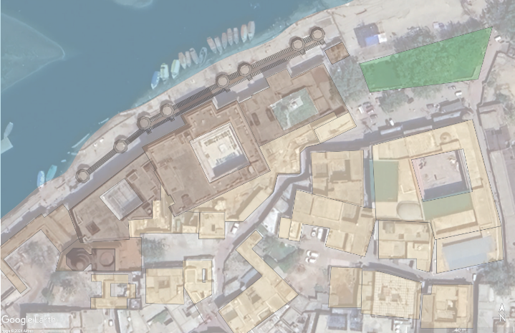
Fig. 1: Initial Documentation of Keshi Ghat
Source: Author, 2024
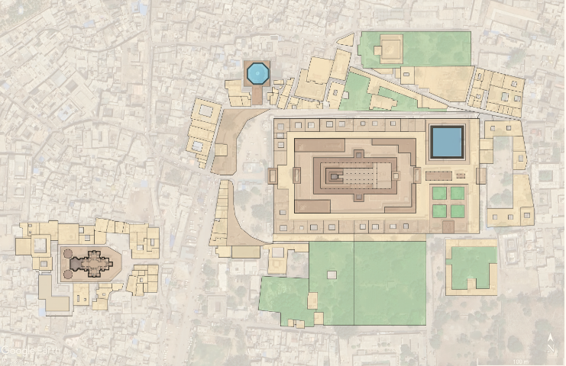
Fig. 2: Rangji Temple and Sri Govinda-Devji Temple
Source: Author, 2024

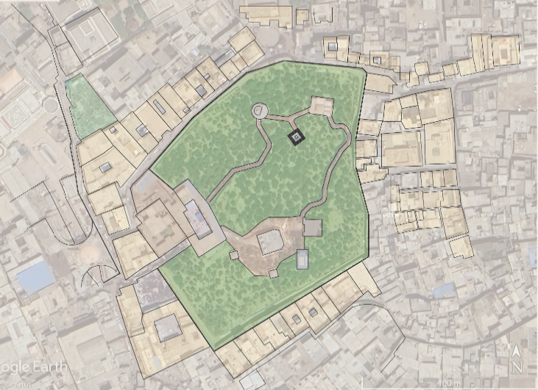
Fig. 3: Nidhivan Sacred Grove
Source: Author, 2024

- Ethnographic Observations: Ethnographic fieldwork was conducted through multiple visits, employing observations of the following:
- Daily rituals (sevas)
- Major festivals: Holi, Ekādaśī)
- Performance traditions (Rāslīlā)
- Food offerings (bhog, prasāda)
- Rhythms of everyday life
- Interactions between devotees, residents, and Goswamis (temple priests)

The observations focused on embodied encounters (Haberman,1994) and framing of enacted landscapes (Sinha, 2014), while also attending to contemporary dynamics of commodification and contestation (Taneja 2023; Gahalot & Gupta 2024).

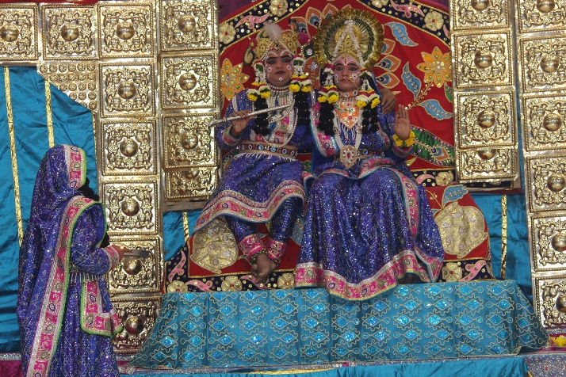
Fig. 4: Darshan of Shri Radha Krishna in blue attire seated on throne at Raas Leela, Vrindavan
Source: Rasik, 2025

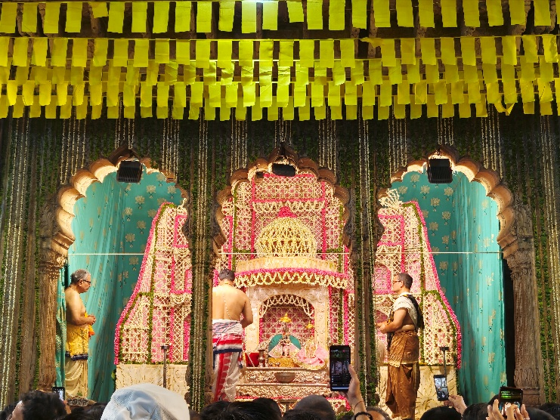
Fig. 5: Phool Bangla Seva, Radha Raman Mandir
Source: Author, 2024

- Oral Histories: Approximately ten informal, open-ended interviews were conducted with pilgrims, devotees, local shopkeepers (including sweet sellers), temple attendants, and residents. These conversations captured:
- cultural narratives
- personal memories
- interpretations of place
- experiential accounts of rituals
- reflections on contemporary transformations
Participants were selected through purposive sampling based on their active engagement with the sites.

- Comparative Analysis: Readings of studies on other Hindu pilgrimage sites (Varanasi, Khajuraho, Puri) and concepts from heritage conservation, contestation (Gahalot & Gupta 2024), and performance studies (Shinde 2010; Mason 2009) were used to contextualize the findings.

As can be seen, this research employs a qualitative, interpretive methodology that integrates archival research, spatial documentation, and ethnography. This mixed-method approach is justified by the subject matter: Placemaking in Braj is enacted across a layered heritage where tangible structures, ritual practices, and narratives interweave to shape spatial identity.
  - Textual Authority: Archival research establishes the mythological and scriptural foundation (e.g., Garga Samhita, Puranas) that imbues the geography with meaning, defining it as the earthly stage for Krishna's divine play (līlā).
  - Spatial Structure: Documentation of routes (parikramā) and sites (kunds, ghats, groves) locates the hierophanies (manifestations of the sacred).
  - Lived Enactment: Ethnographic observation and oral histories capture the performative traditions (like Rāslīlā and parikramā) that continually activate and sustain the landscape's sacredness.
By integrating these three techniques, the study provides a holistic view of the geography-led placemaking continuum, ensuring that the analysis is grounded in both historical narratives and contemporary lived realities.

Despite the comprehensive nature of the research, the study acknowledges the following limitations, which affect the generalizability of the findings.
- Generalizability of the Findings: As an interpretive, qualitative case study focused on specific sites and practices, the findings are not generalizable across the entire 84 Kos Braj region.
- Logistical Constraints on Parikramā: Due to the time-intensive nature of the ritual, detailed fieldwork focused on local circuits (Vrindavan and Govardhan), while the overarching 84 Kos Parikramā tradition was primarily analyzed through existing historical and textual studies (Gupta, 2019).
- Qualitative Sampling: Reliance on informal, convenience sampling for oral histories may introduce bias, though efforts were made to interview a diversity of the members of the community comprised of priests, performers and the residents.

Introduction to the Case Study: The Braj Region

This study examines the placemaking practices in Braj, revealing a system where geography shapes sacred identity, activated by ritual and performance, often preceding temple formalization. The landscape functions as an Eliadean sacred space, a layered palimpsest experienced phenomenologically (Sinha, 2014).
The Braj region (Braj Mandal), investigated as a living sacred landscape, is defined by Krishna's līlā enacted across the geography comprising the Yamuna, the Govardhan hill, the forests (vanas), the groves (kunjas), and the water bodies (kunds), all richly described in Bhakti literature as inherently sacred and beautiful (e.g., Garga Samhita, Brihad Bhagavatamrita). Its identity reflects a deep synergy between Nature, agriculture, and scripture (Chauhan, 2024). The primary structuring element is the 84 Kos Parikramā, a tradition rooted in ancient practice and textual descriptions (Gupta 2019), which ritually defines the sacred territory.

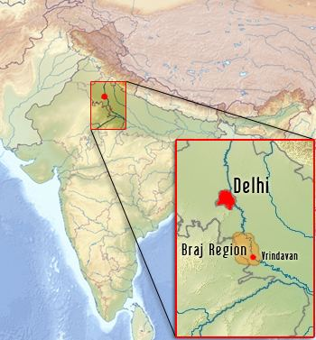
Fig. 6: Braj Region in the Indian Subcontinent
Source: Alchetron, 2024

Findings

Analysis of Data : The analysis reveals placemaking across interconnected typologies, consistently reflecting textual portrayals as follows.

- The Linear Anchor: Yamuna River and its Ghats: Yamuna (goddess) functions as the spine of Braj. Ghats like Vishram Ghat and Keshi Ghat are tangible hierophanies where myth is localized. Rituals continually re-enact these spaces, though pollution challenges their integrity (Sinha, 2014).

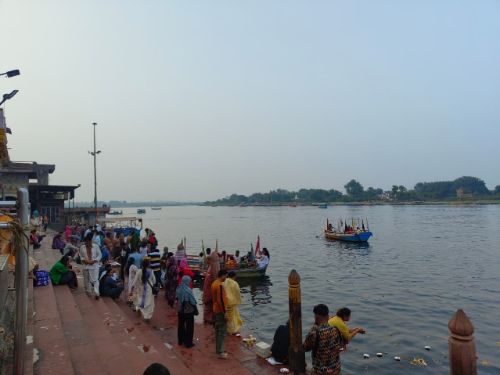
Fig. 7: Vishram Ghat, Mathura, Braj, India
Source: Author, 2024

- The Circumambulatory Anchor: Sacred Hills and Paths: Govardhan Hill (Haberman, 1994; Eck, 2012) amongst other geographical markers also finds sacredness enacted through parikramā. Similarly, the 84 Kos Parikramā (Gupta, 2019) and local circuits (Gulati et al., 2024) define the sacred precincts which are the Punya Kshetra (Singh & Rana, 2023a). These routes transform the geography into living architecture defined by the movements around the sacred centers (Eliade, 1959).

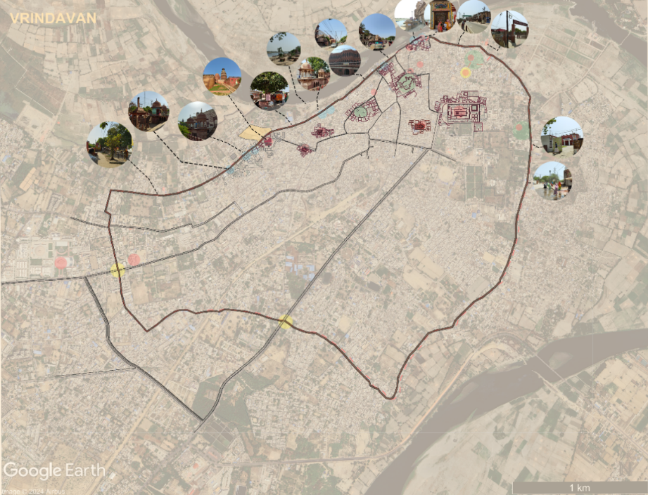
Fig. 8: Vrindavana Dham Parikrama Marg
Source: Author, 2024

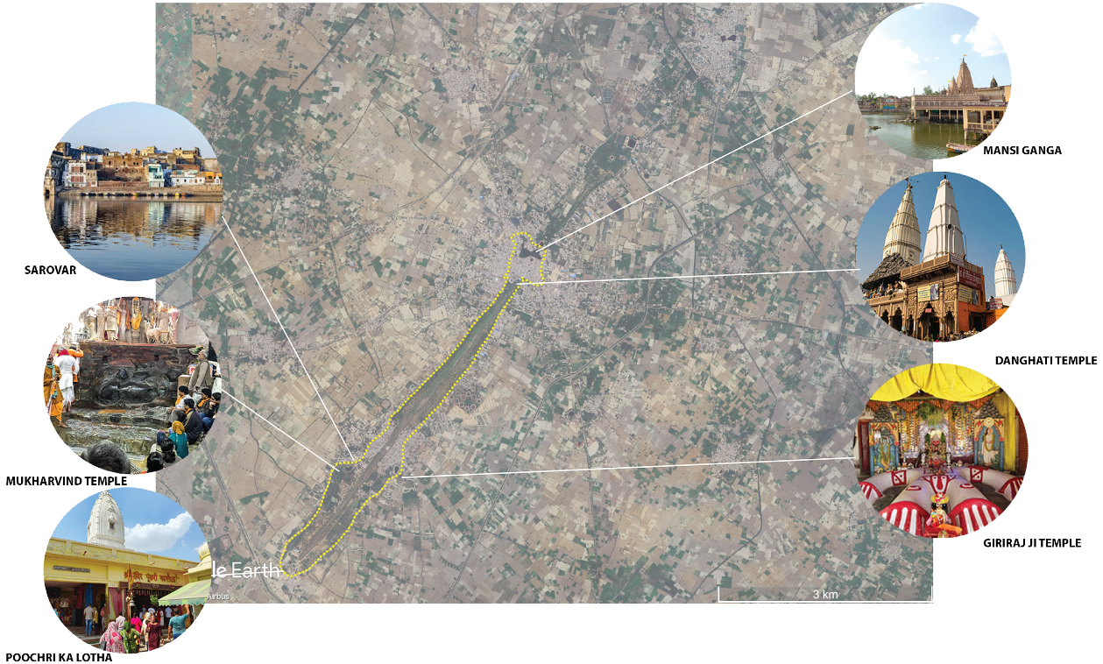
Fig. 9: Govardhan Dham Parikrama Marg
Source: Author, 2024

- The Sacred Reservoir: The Kund as Divine Presence: Water bodies like Radha Kund, Shyam Kund, Mansi Ganga etc. which are considered liquid manifestations of Radha and Krishna themselves, (Eck 2012) are potent hierophanies which can be called Jala Tirthas (Singh & Rana, 2023a). They are described textually as fragrant and beautiful (Brihad Bhagavatamrita). Placemaking centers on ritual immersion (snāna) in these. The sites anchor dense socio-economic fabrics, reinforced by 'foodscapes' as articulated by Singh (2023).
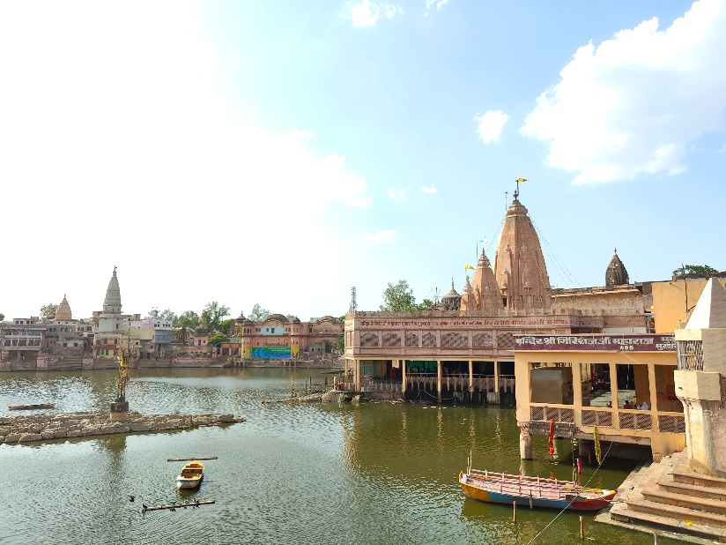
Fig. 10: Manasi Ganga Kund, Govardhan Parikrama
Source: Author, 2024

- The Sacred Grove: The Forest as a Performative Space: Vrindavan itself is textually conceived as a sacred forest (Garga Samhita; Srila Gurudeva), filled with beauty and the divine presence. Specific groves like Nidhivan and Sewa Kunj are intangibly the space of eternal rasa līlā, maintained through narrative and restriction (Haberman, 1994). Devotional texts describe intimate kunjas or nikunjas as settings for divine meetings (Bhajana-Rahasya). Ras mandals within groves serve as stages for Rāslīlā performances, where actors become svarūps, activating sacred time (Mason, 2009; Eliade, 1959). The dvādaśa vana structure the larger Braj Yātrā (Haberman, 1994; Gupta, 2019).

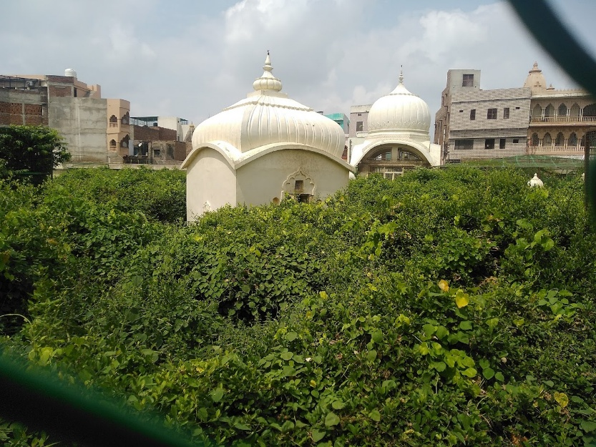
Fig. 11: Seva Kunj, Vrindavan
Source: Apna Yatra, 2023

- The Temple-Geography Nexus and Vernacular Fabric: Temples or Sthān Tīrtha, (Singh & Rana, 2023a) often mark sites already significant, functioning as axis mundi (Eliade, 1959). Vrindavan's core evolved around 16th-century Bhakti movement temples embedded within the vernacular precincts (gheras).

Table 4: The Placemaking Practices at Braj
Source: Author

Sacred Typology (Place) | Textual Foundation (Interpretation) | Specific Placemaking Practice Observed
The Linear Anchor: The Yamuna River and Ghats | Yamuna is the spine (goddess) of Braj Ghats (e.g., Keshi Ghat) are tangible hierophanies where myth is localized. | Ritual immersion (snāna) and daily darshan continually re-enact the space.
The Circumambulatory Anchor: Sacred Paths | Govardhan Hill is interpreted as the body of Krishna. Routes define the sacred territory (Punya Kshetra). | Embodied circumambulation (parikrama) transforms geography into living architecture defined by ritual movement around the sacred centers.
The Sacred Reservoir: The Kund as Divine Presence | Water bodies (e.g., Mansi Ganga) are liquid manifestations of Radha and Krishna (Jala Tirthas). | Ritual immersion (snāna) and water offerings are the central acts of placemaking. These sites anchor the socio-economic fabric reinforced by 'foodscapes.'
The Sacred Grove: The Forest as Performative Space | Vrindavan is textually conceived as a sacred forest (vana) where eternal rasa līlā occurs. Textual kunjas are settings for the divine meetings. | Rāslīlā performance in ras mandals functions as the core placemaking practice, diminishing the distance between the deities and the devotees
The Temple-Geography Nexus | Temples (Sthan Tirtha) often mark the significant sites functioning as an axis mundi. The core evolved around the 16th-century temples embedded in the vernacular precincts (gheras). | Daily sevas (e.g., bhog, prasāda, Phool Bangla Seva) and festival enactments reinforce the sacred core, embedding divinity within the everyday life.

These findings support a descriptive continuum of placemaking: Geography interpreted via texts leads to rituals/performances, which is an enactment, activating sacred time in space. This then leads to community economy and a settlement which shapes the vernacular fabric, foodscapes etc. culminating in temple formalizations which itself is an articulation of the center. Geography, imbued with meaning by devotional narratives, is foundational, continually activated by performance and ritual.

Discussion
The geography-led continuum model contrasts with monument-centric approaches. The dispersed network of natural hierophanies of Braj are interpreted through Bhakti texts and activated by embodied rituals like the 84 Kos Parikramā (Gupta 2019; Haberman 1994). This differs from Varanasi's architecturally dominant riverfront (Singh & Rana, 2023b). The performative dimension (Mason, 2009), deeply rooted in textual descriptions of līlā, is central, aligning with Eliade's (1959) concepts and Sinha's (2014) focus on imagined and enacted landscapes. However, as Shinde (2010) cautions, contemporary performances face transformations.
Braj is increasingly a contested space (Gahalot & Gupta, 2024). Commodification (Taneja 2023) transforms experience. Vrindavan exemplifies pressures: pilgrim traffic strains infrastructure; unregulated construction encroaches on gheras and parikramā paths; pollution degrades the Yamuna and kunds (Sinha, 2014), threatening the efficacy of hierophanies described in texts. 'Heritagization' (Singh & Rana, 2023b) risks prioritizing tourism over living traditions. Interventions like the PRASHAD scheme or local revitalization efforts (e.g., Gulati et al., 2024) must navigate these complexities, addressing the landscape's living, performative, textually-informed, and sometimes contested Nature (Gahalot & Gupta, 2024). In this context, Peleggi's (2021) offers a lens for supporting continuity. The challenge lies in mediating between conservation and community, including agricultural traditions (Chauhan, 2024) and scribal knowledge (Pandey, n.d.), devotional use informed by Bhakti narratives, commodification, and development, respecting the living presence of the landscape (Sinha, 2014).

Conclusions
This case study successfully examined the vernacular placemaking practices of Braj, revealing how its sacred landscapes are produced and sustained through the interplay of geography, devotional texts, ritual, performance, and collective memory. The research contributes a context-specific, synthesized framework for understanding living sacred landscapes, integrating textual portrayals (Bhakti literature), phenomenology, and performance studies to analyse placemaking in contested heritage contexts.
The conclusions confirm that placemaking in Braj is enacted through the embodied interaction between the pilgrims, geography interpreted through devotional texts, and ritual performances, creating a living heritage where natural features function as hierophanies activated by community practice.

Specific Conclusions Derived from the Findings:
- Continuum Validation: The descriptive placemaking continuum (reveals that built structures often articulate pre-existing sacredness rooted in the landscape and its narratives.
- Performance as Placemaking: The core placemaking practice in the Sacred Groves (like Nidhivan) is the Rāslīlā performance, which acts as embodied theology and diminishes the distance between the deities and the devotees by activating sacred time.
- Embodied Sacredness: The physical acts of ritual immersion (snāna) in Kunds (Jala Tirthas) and circumambulation (parikramā) define and sustain the landscape, transforming geography into a living architecture and hierophany.
- Contribution to Rural Culture: These vernacular practices embed divinity within the everyday and sustain cultural identity through narratives and performances, thereby contributing significantly to sacred rural culture and life.

Recommendations for Design and Heritage Intervention
Effective architectural and heritage interventions must adopt a context-specific approach derived directly from the findings of this research, acknowledging the tangible-metaphysical links of Braj's. To enrich heritage and foster social engagement, design must intervene to support cultural continuity and address contestation by:
- Respecting Geography as Presence: Architectural design must respect the geographical features (Yamuna, Govardhan, Kunds) as sacred presence informed by devotional texts.
- Supporting Ritual and Performance: Prioritizing the maintenance of infrastructure (e.g. ghats, parikramā paths) and spaces (ras mandals) that enable the core practices like parikramā and Rāslīlā.
- Integrating Ecology and Vernacular Forms: Addressing environmental degradation (pollution of Yamuna) while engaging the community and respecting the synergy between Nature, agriculture, and scripture.
- Spatial Storytelling: Utilizing scriptural narratives to inform spatial design, thus sustaining the cultural resonance of the landscape while integrating the contemporary functions.

Acknowledged Limitations
The limitations of the study include its qualitative scope (findings are interpretive, not generalizable), logistical constraints on fully documenting the entire 84 Kos Parikramā circuit, and reliance on convenience sampling for oral histories.

Directions for Further Research
New directions for further research include:
- Comparative Analysis: Investigating the placemaking continuum in other Krishna pilgrimage sites to refine the model's transferability and cultural specificity.
- Design Intervention Studies: Action research focused on applying the derived design principles (e.g., spatial storytelling, devotional conservation) in pilot projects to measure their impact on community engagement and cultural continuity.
- Economic Impact Assessment: Quantifying the economic contribution of traditional parikramā and performance practices versus large-scale tourism infrastructure.

Acknowledgements: Please offer acknowledgements of any support received; financial or otherwise.

Ethical Conduct: Please make a statement about the ethical manner in which this research has been conducted.

Availability of Data: Please make a statement about the availability of data from each of the data gathering techniques if requested by any legitimate party to ascertain the truthfulness of the claims.

Conflict of Interest: Please make a statement about any conflict of interest involved in this study and the paper.

References

Bhardwaj, S. M. (1983) Hindu places of pilgrimage in India: A study in cultural geography Vol. 14(?) page numbers?. Berkeley, CA: University of California Press.
Business Standard. (2015, May 10). NGT intervenes to save Vrindavan from garbage threat. Retrieved from https://www.business-standard.com/article/news-ians/ngt-intervenes-to-save-vrindavan-from-garbage-threat-115050200274_1.html
Chaturvedi, S. K. (n.d.) A brief history and Sanskriti of Braj-Bhoomi. Retrieved from https://ia903407.us.archive.org/5/items/Pushtimarg/Culture%20Of%20Braj%20%28English%29.pdf
Chauhan, A. S. (2024) The cultural heritage of Braj, India: Exploring the synergetic influence of nature, agriculture and scripture. Creative Saplings, 3(12), 123–140. https://doi.org/10.56062/gtrs.2024.3.12.831
Dhan Gahalot, R. & Gupta, C. (2025) Regenerating and reclaiming the contested spaces in sacred landscapes. Archaeologies, 21(1), 74–100. https://doi.org/10.1007/s11759-024-09512-w
Eck, D. L. (2012) India: A sacred geography. New York, NY: Harmony Books.
Eliade, M. (1959) The sacred and the profane: The nature of religion (W. R. Trask, Trans.). New York: Harcourt, Brace & World.
Entwistle, A. W. (2025) Braj, centre of Krishna pilgrimage. Vol. (3). Leiden: Brill.
Gulati, R., Sehgal, V. & Sanyal, A. (2024) Revitalization of cultural landscape: Barsana in Braj Mandal. World Journal of Innovative Research, 16(6), 1–10. https://doi.org/10.31871/WJIR.16.6.6
Gupta, V. K. (2019) Braj 84 Kos Parikramā: History, tradition and archaeology. [Publisher unknown].
Haberman, D. L. (1994) Journey through the twelve forests: An encounter with Krishna. New York: Oxford University Press.
Mason, D. V. (2009) Theatre and religion on Krishna’s stage: Performing in Vrindavan. New York: Palgrave Macmillan.
Millennium Post. (2024, July 18). Mathura–Vrindavan hit by rising Yamuna. Retrieved from https://www.millenniumpost.in/big-stories/mathura-vrindavan-hit-by-rising-yamuna-626408
Norberg-Schulz, C. (1980). Genius loci: Towards a phenomenology of architecture. New York, NY: Rizzoli.
Pandey, S. (n.d.). Scribal traditions of Braj: Bridging literary cultures and historical narratives. Retrieved from https://bharatiya-jnana-sarita.info/pdfs/DrSurabhiPandey.pdf
Peleggi, M. (2021). A theory of devotional conservation: A preliminary proposal. Academia Letters, Article 189. https://doi.org/10.20935/AL189
Prem Sāgar; Bhāgavata Purāṇa; Bhajana-Rahasya; Bhakti-rasāmṛta-sindhu; Bṛhad-Bhāgavatāmṛta; Chaitanya Bhāgavata; Chaitanya Maṅgala; Garga Saṁhitā; Tiruvāymoḻi. (2025). Vrindavana – Concept and References in Scripture. Wisdom Library. Retrieved from https://www.wisdomlib.org/concept/vrindavana
Rapoport, A. (1969) House form and culture. Englewood Cliffs, NJ: Prentice-Hall.
Ray, S. (2019) Climate change and the art of devotion: Geoaesthetics in the land of Krishna, 1550–1850. Seattle, WA: University of Washington Press.
Relph, E. (1976) Place and placelessness. London: Pion.
Shinde, K. A. (2010) Sacred landscape, sacred performances: Connection and cacophony. In R. P. B. Singh (Ed.), Holy places and pilgrimages: Essays on India (127–146). Retrieved from: https://www.researchgate.net/publication/276849445_Sacred_Landscape_Sacred_Performances_Connection_and_Cacophony
Singh, R. P. B. (1997) Sacred space and pilgrimage in Hindu society: The case of Varanasi. In R. H. Stoddard & A. Morinis (Eds.), Sacred places, sacred spaces: The geography of pilgrimages (191–207). Baton Rouge, LA: Louisiana State University Press.
Retrieved from: https://archive.org/details/sacredplacessacr0000unse/page/n5/mode/2up
Singh, R. P. B. (2009) Cosmic order and cultural astronomy: Sacred cities of India. Newcastle upon Tyne: Cambridge Scholars Publishing. Retrieved from: https://www.academia.edu/14952692/04_PECU_Singh_Rana_P_B_2009_Cosmic_Order_and_Cultural_Astronomy_Sacred_Cities_of_India_Foreword_Prof_John_McKim_Malville_U_S_A_Planet_Earth_and_Cultural_Understanding_Series_Pub_4_Cambridge_Scholars_Publishing_Newcastle_upon_Tyne_U_K_xvi_249pp_15_tables_72_figures_
Singh, R. P. B. (2023) Symbolism, sacrality and foodscapes in Hindu pilgrimage systems. In D. Munro, N. Buttigieg & D. H. Olsen (Eds.) Food and the pilgrim: Nourishment for pilgrims and faith-based tourists (201–220). Oxford: Peter Lang. Retrieved from: https://www.academia.edu/105368594/_825_23_Singh_Rana_P_B_2023_Symbolism_Sacrality_and_Foodscapes_in_Hindu_Pilgrimage_System_In_Dane_Munro_Noel_Buttigieg_and_Daniel_H_Olsen_eds_Food_and_the_Pilgrim_Nourishment_for_Pilgrims_and_Faith_Based_Tourists_pp_201_220_chapter_12_Peter_Lang_Oxford
Singh, R. P. B. & Dubey, D. P. (1988) Mathurā Mandala: Territory and sacrality. In T. P. Verma, S. Saran & D. P. Singh (Eds.), Yuga-Yugina Braj: A history of Braj region (189–200). Varanasi: Bhartiya Itihas Samkalan Samiti. Retrieved from: https://www.researchgate.net/publication/320097797_080-88_Singh_Rana_PB_and_Dubey_DP_1988_c_Mathura_Mandala_Territory_and_Sacrality_in_Verma_T_P_Saran_S_and_Singh_DP_eds_Yuga-Yugina_Braj_A_History_of_Braj_Region_Bhartiya_Itihas_Samkalan_Samiti_Varanas
Singh, R. P. B. & Rana, P. S. (2022) Geography of tourism and pilgrimages. In S. C. Rai (Ed.), Progress in Indian geography: A country report, 2016–2022 (230–267). New Delhi: INSA.
Singh, R. P. B. & Rana, P. S. (2023a) Geography of Hindu pilgrimage places (Tirthas) in India. In L. Lopez (Ed.), Geography of world pilgrimages (297–322). Cham: Springer Nature. https://doi.org/10.1007/978-3-031-32209-9_14
Singh, R. P. B. & Rana, P. S. (2023b) The riverfrontscapes of Varanasi, India: Architectural symbolism, transformation, and heritagization. EdA Esempi di Architettura, 10(2), 244–269. Retrieved from: https://www.researchgate.net/publication/368569844_78423_Singh_Rana_PB_and_Rana_Pravin_S_2023_The_Riverfrontscapes_of_Varanasi_India_Architectural_symbolism_transformation_and_heritagization_EdA_Esempi_di_Architettura_International_Journal_of_Architec
Sinha, A. (2006) Landscapes in India: Forms and meanings. New Delhi: Foundation Books.
Sinha, A. (2014) The sacred landscape of Braj, India: Imagined, enacted, and reclaimed. Landscape Journal, 33(1), 59–75. https://doi.org/10.3368/lj.33.1.59
Taneja, L. (2023) Losing and finding Braj: Commodification and entrepreneurship in the sacred land of Krishna. Religions, 14(5), 643. https://doi.org/10.3390/rel14050643
The Statesman. (2017, August 25) Unbridled construction erodes Vrindavan’s ecology. Retrieved from https://www.thestatesman.com/cities/unbridled-construction-erodes-vrindavan-s-ecology-1486533898.html

