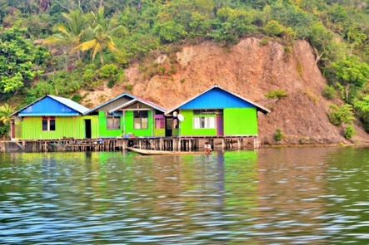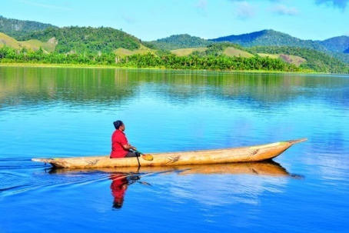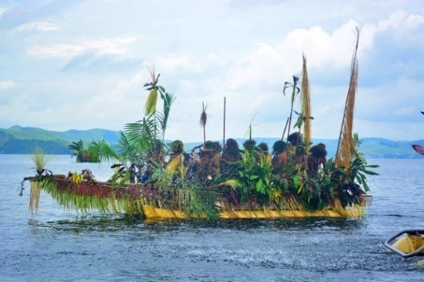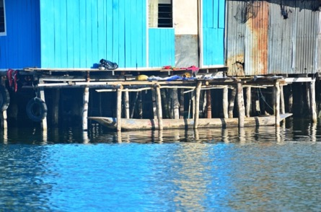

|  |  |
| --- | --- |
| **EDITORIAL**  **Dr. Ranjith Dayaratne**, Asian School of Knowledge, Colombo, Sri Lanka**.** | **i** |
| **Blending Architecture with Nature: Concepts of Sundanese Architecture and their Applications in Contemporary Architecture in Kampung Naga, Indonesia**  M. Maria Sudarwani, Tisya Putri S. & Petra Renatta | **1**  **1-14** |
| **Pracimosono as a Place of Intimacy and Spiritual Experience of the Mangkunegaran Princesses**  **in Surakarta, Indonesia**  Dhian Lestari Hastuti, Achmad Syarief, Imam Santosa & Pribadi Widodo | **2**  **15-38** |
| **Symbolic Meanings of Noble Values in Srandul Art in Kampung Bumen, Kotagede, Indonesia**  Shubuha Pilar Naredia, & Sunarmi | **3**  **39-47** |
| **Conservation of Urban Heritage Landscapes: Lessons from Souq Al-Saffarin in Baghdad, Iraq**  Rasha albayati & Dhirgham Alobaydi | **4**  **48-61** |
| **Anti-colonialism During Suharto’s New Order Era and its Impact on Conservation of Architecture in Indonesia**  Yanita Mila Ardiani, Kemas Ridwan Kurniawan & Yulia Nurliani Lukito | **5**  **62-71** |
| **“Mamuli” Pattern in East Sumba Woven Fabric as Inspiration For “Kandunnu” Standing Lamp**  **Using the IMOE Method**  Erwin Ardianto Halim, Eakachat Joneurairatana, Jirawat Vongphantuset, & Pairoj Jamuni | **6**  **72-89** |
| **Local Wisdom of the Begalan Tradition in Traditional Weddings: Insights from Banyumas, Central Java, Indonesia**  Aulia Sholichah Iman Nurchotimah, Sapriya, Siti Nurbayani K, Susan Fitriasari,  Anwar Sanusi & Rizky Amelia | **7**  **90-102** |
| **Physical Changes and Spirit of Place of the Puri Karangasem Area in Bali, Indonesia**  Anak Agung Ayu Agung Candra Dewi, Naniek Widayati Priyomarsono  & Samsu Hendra Siwi | **8**  **103-122** |
| **Development of Traditional Communities of the Khabarovsk Territory During the Population Policy of 1970s-1980s of Russia**  Akhmetova Anna Valinurovna, Musalitina Evgeniya Aleksandrovna,  Gorelikov Andrey Ivanovich & Jalilova Shems Sardar kyzy | **9**  **123-135** |
| **Expressions of National Identity in the Landscape Architecture Projects in Kazakhstan**  Nina Kozbagarova & Meruyert Srail | **10**  **136-145** |
| **Seismic Effects on the Stone Masonry of Rubik Church in Albania: Interaction Modeling of Different Masonry Panel Types**  Ervin Paci | **11**  **146-167** |
| **Maintaining Identity of the Built Environments of Religious Cities: Impact of Expansions at the Historic Karbala, on the Vernacular Communities in Iraq**  Ali Raoof Hussein Al Sultan & Ali Aumran Lattif Al-Thahab | **12**  **168-190** |
| **Adaptive Reuse of Heritage Buildings for Sustainable Urban Regeneration: Two Case Studies from India**  R. J. Vidyullatha, G. Viswanadha Kumar & G. Dileep | **13**  **191-214** |
| **Reciprocal Relationships between the Artistic Expressions of the Isolo Performance of Sentani Tribe with the Spatial Contexts of the Putali Village, Indonesia**  Ida Bagus Gede Surya Peradantha, Sri Rochana Widyastutieningrum,  Santosa Soewarlan & Ida Bagus Gde Yudha Triguna | **14**  **215-231** |
| **Thomas Hobbes' Views on the Notion of Power in "Leviathan" and their Manifestations in Human Settlements in Vietnam**  Tuoi Thi Tran | **15**  **232-245** |
| **Maintaining Sense of Place in a Historic Village: Insights from the Pekalongan Arabic Village, Indonesia**  Mohammad Sahid Indraswara, Atik Suprapti, Agung Budi Sardjono,  Muhammad Fariz Hilmy & Septana Bagus Pribadi | **16**  **246-259** |