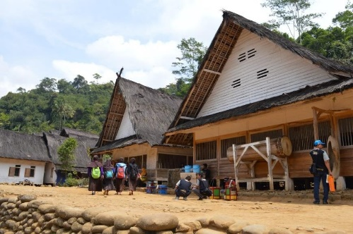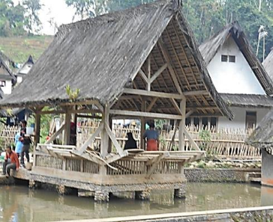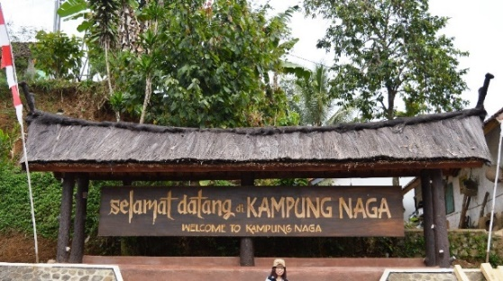

|  |  |
| --- | --- |
| **EDITORIAL**  **Dr. Ranjith Dayaratne**, Asian School of Knowledge, Colombo, Sri Lanka**.** | **i** |
| **Blending Architecture with Nature: Concepts of Sundanese Architecture and their Applications in Contemporary Architecture in Kampung Naga, Indonesia**  M. Maria Sudarwani, Tisya Putri S. & Petra Renatta | **1**  **1-13** |
| **Transformations of Residential Neighborhoods of Rajshahi: The Case of Sagarpara and Padma Residential Areas in Bangladesh**  Sheikh Hameem, Sabbir Ahmed Siddique, Abir Rahman & Md. Masum Billah Tarafder | **2**  **14-23** |
| **Influence of Graffiti on People’s Perceptions of Urban Spaces in Hashemi Shamali, Amman, Jordon**  Majd Albaik | **3**  **24-45** |
| **Climate and Seismic Responsive Vernacular Architecture of the Old Settlement of Srinagar, India**  Annam Ishrat, Naveen Suresh Chomal, Anuska Mahalik & Mohammad Arif Kamal | **4**  **46-61** |
| **Between Aesthetics and Functions: Use of Traditional Batik Motifs in Urban Interiors in Indonesia**  Eko Sugiarto, Abdul Halim bin Husain, Muh Ibnan Syarif,  Putri Khoirin Nashiroh, & Meina Febriani | **5**  **62-76** |
| **Handicraft Innovations: A Strategic Approach to Preserving Intangible Cultural Heritage of Malaysia**  WN Jazmina W. Ariffin, Syed Shahfiq, Fazil Ahmad, Asmawi Ibrahim,  & Farah Syazrah Ghazalli. | **6**  **77-86** |
| **Application of Traditional Mantingan Motifs in New Wood Carving Art Design in Indonesia**  Eko Haryanto, Mujiyono, & Nadia Sigi Prameswari | **7**  **87-102** |
| **Cultural Expressions of Vernacular Architecture of Eclectic Style: The Case of Dharma Rakhita Temple in Jamblang, Indonesia**  Elizabeth Susanti Gunawan, Krismanto Kusbiantoro, & Erwin Ardianto Halim | **8**  **103-118** |
| **Psychological Relationships Between**  **Heritage Buildings and their Occupants: A Theoretical Exploration**  Zahraa Ahmed & Saba Sami Al Ali | **9**  **119-138** |
| **Using Information System Simulations and Modeling to Reconstruct Traditional Building Structures: The Case of Joglo Buildings in Indonesia**  Lilik Setiawan HP, Syarifuddin Madenda, Eri Prasetyo Wibowo  & Raziq Hasan | **10**  **139-154** |
| **Experiencing Vernacular Streets as Urban Heritage Sites: Sense of Place of Historic Streets in Kayutangan, Malang, Indonesia**  Magvira Ardhia Pratiwi, Jenny Ernawati & Yusfan Adeputera Yusran | **11**  **155-172** |
| **Principles of Literary Education in Vernacular Settlements: Insights from the Sastra Pinggiran Banyumas Community in Indonesia**  Meina Febriani, Agus Nuryatin, R.M. Teguh Supriyanto, & Hari Bakti Mardikantoro | **12**  **173-189** |
| **Vernacular Contribution to Dutch East Indies Heritage Architecture in Indonesia:**  **Insights from the Jaarbeurs Building**  Sriwinarsih Maria Kirana, Kreangkrai Kirdsiri, & Antonello Alici | **13**  **190-203** |
| **Architectural Adaptations and Spatial Reconfigurations for the Ngerebeg Dance Performance in Pura Dalem Kangin in Indonesia**  Ida Ayu Wimba Ruspawati | **14**  **204-220** |
| **Transformations of Vernacular Artisan Settlements in India: Insights from Odisha**  Bharati Mohapatra | **15**  **221-236** |
| **Tambale as a Determinant of Residential Spatial Planning in The Kaili Ledo Community, Central Sulawesi, Indonesia**  Irdinal Arief, T. Yoyok Wahyu Subroto & Syam Rachma Marcillia | **16**  **237-251** |
| **The Role of Urban Spaces in Creating Socially Cohesive Neighborhoods: The Case of Walled City of Jaipur, India**  Manjari Rai | **17**  **252-264** |